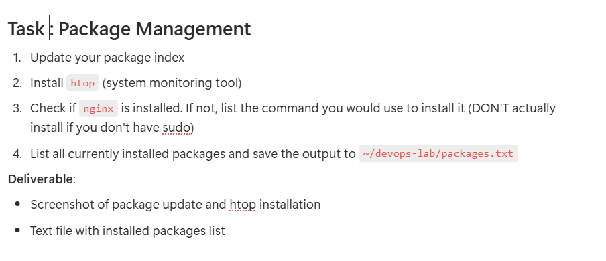
Solution:
- Update your package index
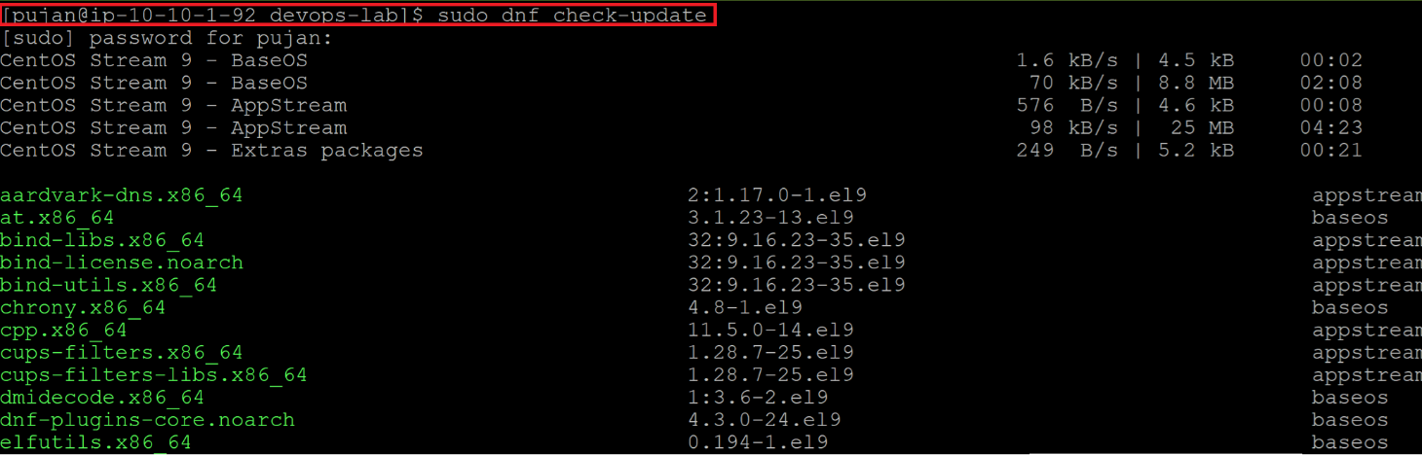

- Install htop (system monitoring tool)
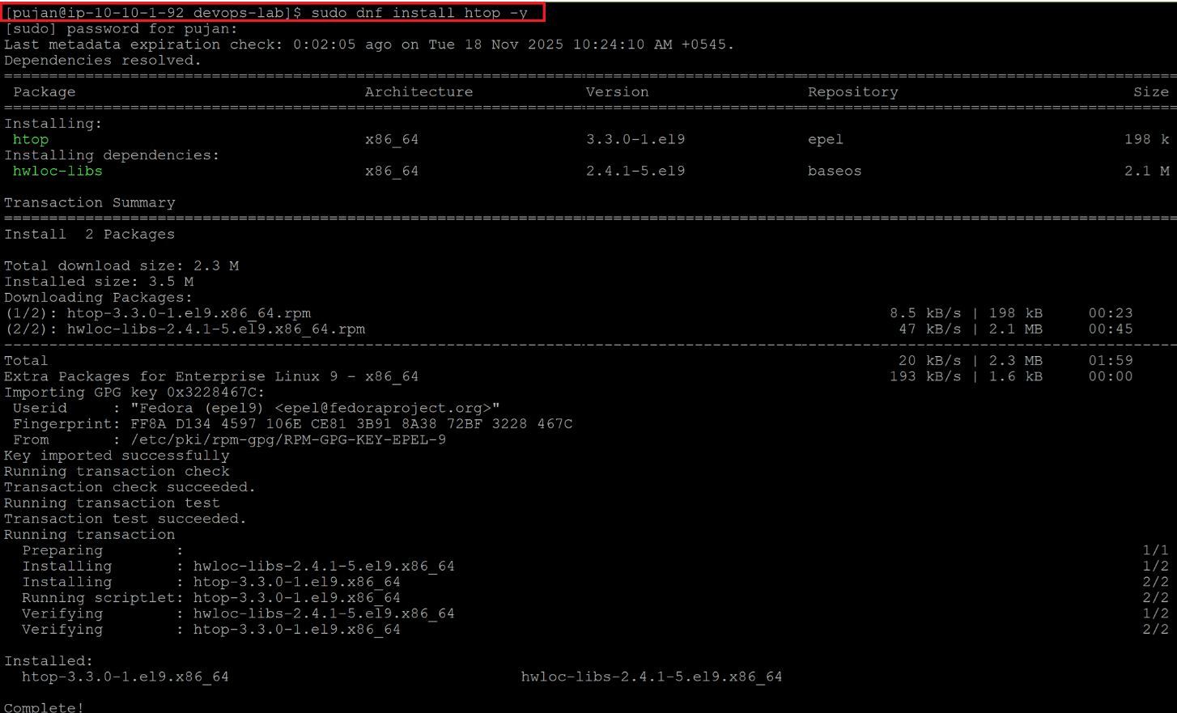
- Check if nginx is installed. If not, list the command you would use to install it (DON’T actually install if you don’t have sudo)
To check if nginx is installed:
nginix -v OR rpm -qa | grep nginx
To install it:
sudo apt install nginx -y
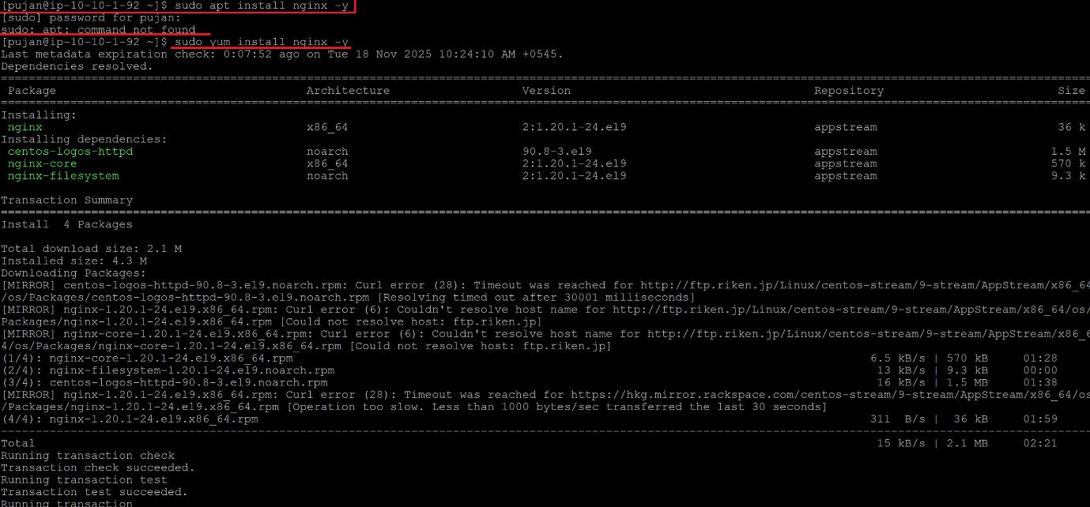
- List all currently installed packages and save them to ~/devops-lab/packages.txt
